Contagion Web Game

# Overview

Players try to get the population of a fictional continent to be loyal to their ideology by spreading it across countries. To do this, players spend their resources to deploy various agents to different countries on the continent. Agents represent actual people handing out pamphlets, a television marketing campaign, a twitter account, renting a billboard on a busy freeway, or any other way that people share ideas with each other. Players gain resources every turn based on the number of agents deployed and amount of population loyal to them. The continent is broken up into a predefined number of countries. Each country is further broken up into predefined number of territories. The territory’s population is represented by a percentage of people loyal to a player and those who have no assigned loyalty.

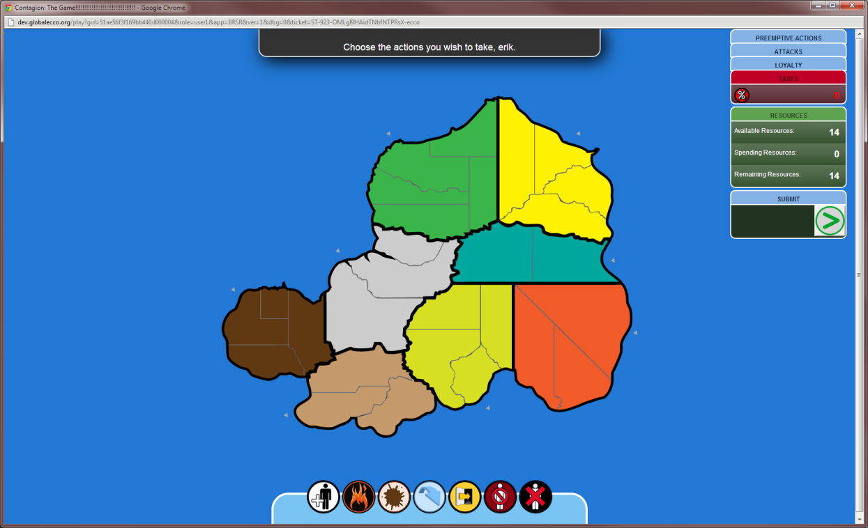

# Objective

A player wins the game when he controls half the countries (i.e. has 100% of the population in all the territories of that country) on the continent or has at least some percentage of loyalty from the majority of territories in the continent. For example, if there are 28 territories on the continent, a player with 15 territories with some percentage of loyalty would win the game.

# Setup

The game starts with the players:

* Choosing a color to represent them
* Choosing a country to place their first agent in
* Entering a name for their ideology

# Turn Flow

A normal game turn proceeds as follows:

1. Each player purchases actions they wish to take for that turn
2. Once all players have submitted actions, the game state updates
3. Players gain resources based on the current state of the game

# Player Actions

## Recruit

Create additional agents and place them in a country of the player’s choice.

## Move

Transfer an agent from one country to another. The agent will start converting the population on the same turn.

## Boost

Increase the country’s agents’ rate of loyalty spread to the neutral population in that country’s territories. If two players Boost in the same country on the same turn, then the player with the greater number of agents will cause those additional agents to spread the loyalty (e.g. Player A Boosts two agents, Player B Boosts one. Only one of Player A’s agents will spread the loyalty and no territories will spread the loyalty.)

## Attack

Decrease the percentage of loyalty to another player’s ideology in a specific country. Each agent in the country and the territories with 50% or more loyalty toward the player will assist in decreasing the population loyal to the opponent. This action can only be used when the player has an agent in a country and that country has territories with some loyalty towards an opponent.

## Escape

Move an agent out of a country before any other actions are applied. The player can’t Move any other agents into this country this turn. This action can only be used when there are opposing agents in the same country.

## Disable

Temporarily remove another player’s agent from the game. The other player will have to perform a Move action to bring the agent back into play. This action can only be used when the player has an agent in the same country as the opponent’s agent.

## Remove

Destroy another player’s agent. The other player loses that agent. This action can only be used in a country that has both the player’s agent and an opponent’s agent.

# Game State Update

## Commit Actions

Actions are computed in the following priority order:

1. All Escape actions happen
2. All Disable/Remove actions happen
   1. If the player has no more agents in a country, all actions they would have performed are cancelled
3. Any country that has a Boost by one player and an Attack on that same player from an opponent cancel each other out
4. All remaining actions happen simultaneously

|  |  |  |
| --- | --- | --- |
|  | **Player B Boost** | **Player B Attack** |
| **Player A Boost** | The player with the most agents spread loyalty. Territories do not spread loyalty. | No-op |
| **Player A Attack** | No-op | Both players lose loyalty |

## Spread Loyalty

Loyalty to a player’s ideology is spread using the following rules:

* A player must have at least one agent in a country to convert that country’s population.
* Agents will convert the population of the territory with the player’s highest loyalty percentage first. When that territory is 100% converted, the agent will start converting the next available territory in that country.
* Territories with more than 50% loyalty to a player will start spreading loyalty to the next available territory in that country.
* If a country has agents from two or more players:
  + Only the agents from the player with the most agents will spread their loyalty to the territories within that country.
* When a player’s loyalty spreads into a territory that’s loyal to an opponent, that territory’s population gets converted to a neutral loyalty first before converting to the player’s loyalty.

## Generate Resources

A player gains resources based on the following criteria:

* Each player gets 1 resource point per turn
* Players acquire resources for every controlled country equal to the number of territories in that country, minus 1
* Players who have 5-9 territories in the continent with some percentage of loyalty acquire an additional 2 resource points
* Players who have 10 or more territories in the continent with some percentage of loyalty gain an additional 3 resource points
* Players who have more than one agent in play lose 1 resource point for each additional agent after the first.